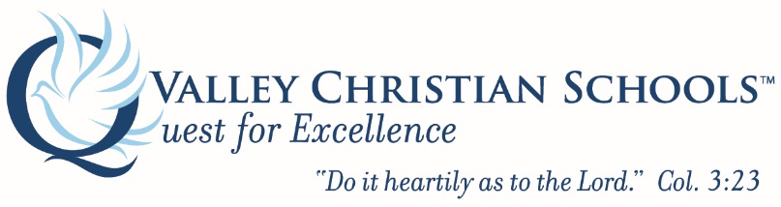

Job Title: Pool Operator

Job Family: Classified – Non Instructional

Reports To: Director of Operations

Number/Titles of Subordinates: None

Peers: Custodial Staff, Maintenance Staff

EEO: Technicians

N/E: Non-Exempt

Main Purpose of the Position: To maintain a clean and safe pool environment for teachers, students and outside renters to perform swimming and other water activities. Duties include a variety of administrative and maintenance duties in the Operations office.

Christian Role Model Commitment:
- Express a testimony of a personal relationship with God through Jesus Christ.
- Serve as a Christian role model and a consecrated Christian, dedicated to the purpose and goals of the Christian school.
- Have an understanding of the philosophy and objectives of Valley Christian Schools.
- Be regular in attendance at a Christian Bible believing church of your choice.
- Be agreement with the VCS Statement of Faith and be committed to daily prayer and spiritual growth. (I Tim. 1:3; I Tim. 2:1-8; I Tim. 3:1-13; I Thess. 5:11-28; Rom. 12:14-21; Rom.14: 4; Gal. 6:1-10).

Personal and Professional Qualifications:
- Have a proven evidence of adequate preparation, background and ability required by the position.
- Be committed to implement and enforce policies and follow prescribed procedures.
- Have the skill to make and effectively communicate timely decisions.
- Have the ability to foster creativity and be responsible for innovative ideas.

List Job Duties:
  - Swimming Pool
- Chemical testing of the pool and logging test results.
- Removal of debris from the pool.
- Vacuuming of pool with portable unit.
- Brushing of walls and bottom and needed.
- Checking of safety equipment racks and ladders.
- Perform daily, weekly, monthly and annual maintenance tasks as instructed by supervisor
- Assist with set-ups for water polo games, swim meets and other pool related events

  - Equipment Room
- Check flow meters, pressure gauges, temperature gauges and timers.
- Adjust chemical feeders when needed.
- Record pool readings on log sheet.
- Clean debris from circulation pump traps.
- Visual inspection of pool deck and equipment: heaters, pumps and filters.
- Perform daily, weekly, monthly and annual maintenance tasks as instructed by supervisor
- Maintain clean and safe work environment.

  - Repair and Special Circumstances
- Notification of equipment problems to Director of Operations.
- Get written or verbal approval for any repairs.
- Get written schedule from the Director of Operations for available cleaning hours.
- Emergency service is available via home telephone and cell phone.

Essential Functions:
- Perform duties to ensure pool is safe and clean for students and coaches to conduct water activities.
- Notify Director of Operations of any need for pool equipment repair or maintenance; ensure work is performed correctly and pool is safe.

Non-Essential Functions:
None
Supervisory Responsibilities:
No supervision.
Knowledge and Skills:
- Ability to read and comprehend written instructions, including pool equipment maintenance manuals. Ability to write correspondence. Ability to effectively present information to peers and supervisors and small group situations to customers, clients, and other employees of the organization.
- Ability to deal with problems involving several concrete variables in standardized situations.
- Ability to perform and/or understand math and chemistry equations to maintain proper chemical levels in the pool.
- Associate degree at two year college. Or one to two years related experience and/or training; or equivalent combination of education and experience.

Fiscal Responsibilities: (Budget responsibilities, approval privileges, reporting and auditing)
N/A.

Extent of Public Contact: (Type and frequency)
Daily contact with teachers, coaches, students, guests and school administrators

Physical Demands: lifting, walking, equipment operations
The physical demands described here are representative of those that must be met by an employee to successfully perform the essential functions of this job. Reasonable accommodations may be made to enable individuals with disabilities to perform the essential functions.
While performing the duties of this job, the employee is regularly required to use hands to finger, handle, or feel and talk or hear. The employee frequently is required to walk and reach with hands and arms. The employee is occasionally required to stand; sit; and stoop, kneel, crouch, or crawl. The employee must be able to swim, dive and quickly respond to pool emergency situations. The employee must be able to lift and/or move up to 100 pounds. Specific vision abilities required by this job include close vision, distance vision, color vision, peripheral vision, depth perception, and ability to adjust focus.
Working Conditions and Environment: travel, usual work hours, environmental conditions
The work environment characteristics described here are representative of those an employee encounters while performing the essential functions of this job. Reasonable accommodations may be made to enable individuals with disabilities to perform the essential functions.
While performing the duties of this job, the employee is frequently exposed to outside weather conditions. The employee is occasionally exposed to wet and/or humid conditions. The noise level in the work environment is usually moderate to loud.
This position is not required to travel.

